Segment–Line Collinearity
# Source: AI Source: Provided by: [Data Path: Persons Table -> ID Column: 1, Name_En Column: Motasem Essam] -> From: [ChatGPT] on [7/25/2026]
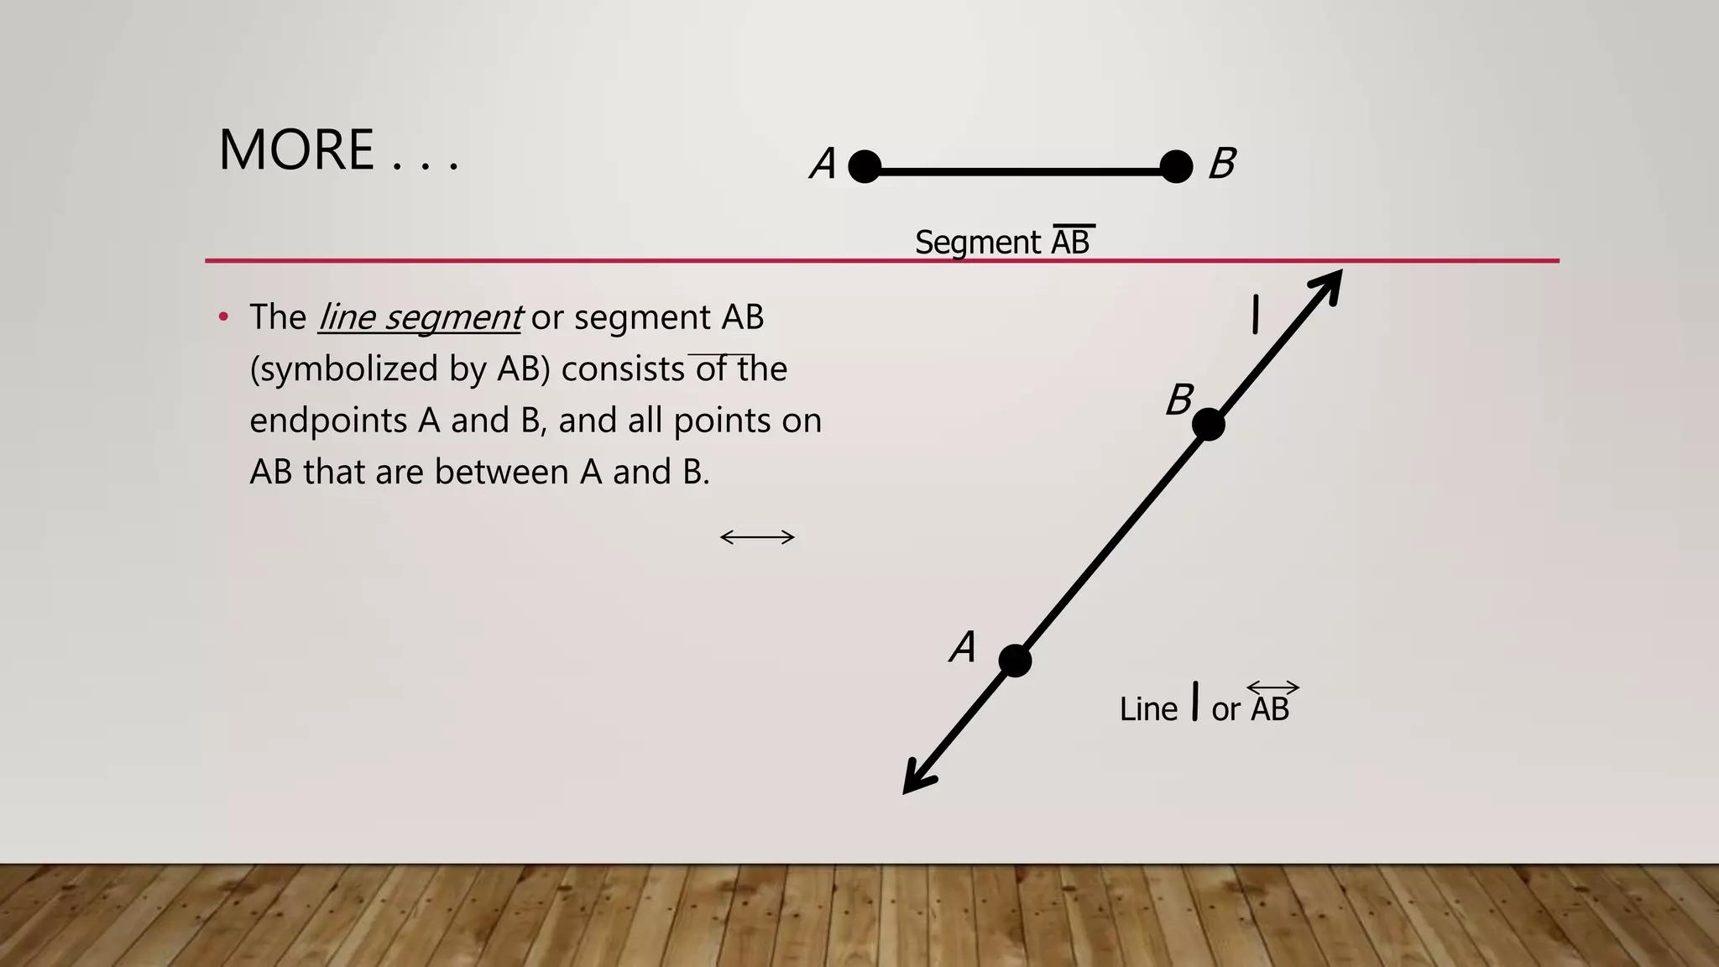
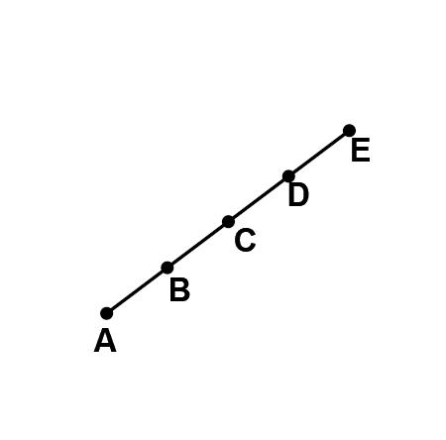
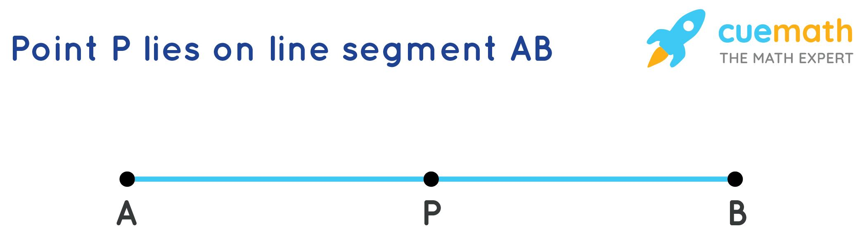
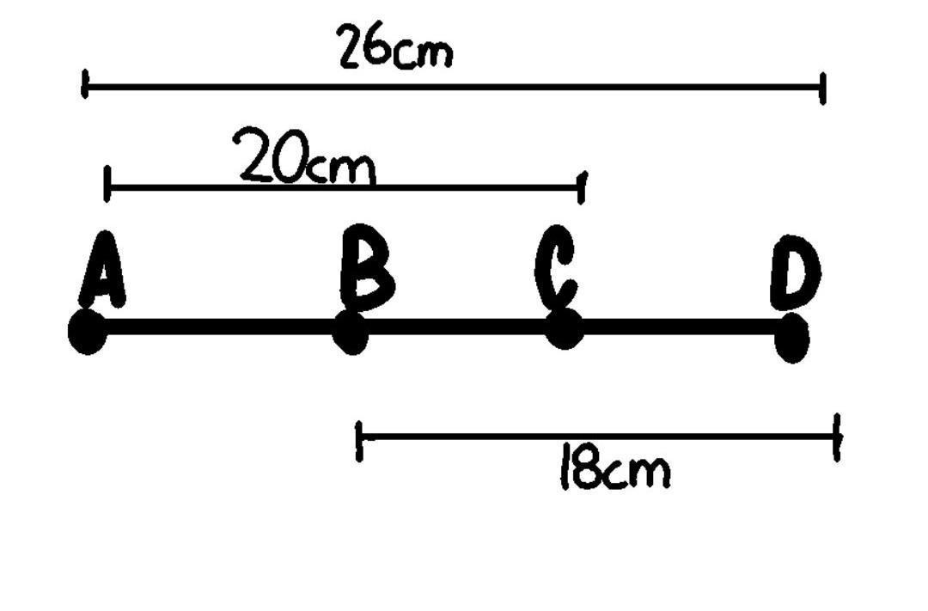

Definition
# Source: AI Source: Provided by: [Data Path: Persons Table -> ID Column: 1, Name_En Column: Motasem Essam] -> From: [ChatGPT] on [7/25/2026]
Segment–Line Collinearity is a geometric relationship in which a line segment lies on a given straight line.
For a line segment $\overset{‾}{AB}$and a line $l$, they are segment–line collinear when:
$$\boxed{\overset{‾}{AB}⊆l}$$
That means every point of the segment belongs to the line.
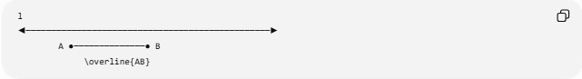
l
◀────────────────────────────────────────────────▶
A ●──────────────● B
\overline{AB}
The segment is a finite portion of the infinite line.

Fundamental Concept
# Source: AI Source: Provided by: [Data Path: Persons Table -> ID Column: 1, Name_En Column: Motasem Essam] -> From: [ChatGPT] on [7/25/2026]
A line extends infinitely in both directions:
◀──────────────────────────────────────────────▶
l
A segment is finite and has two endpoints:
A ●────────────────────● B
When the segment lies on the line:
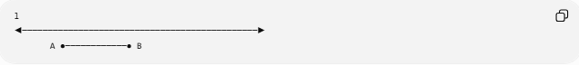
l
◀──────────────────────────────────────────────▶
A ●────────────● B
the segment and line have the same straight-line alignment.
Therefore:
$$\boxed{\overset{‾}{AB}⊆l}$$

Mathematical Representation
# Source: AI Source: Provided by: [Data Path: Persons Table -> ID Column: 1, Name_En Column: Motasem Essam] -> From: [ChatGPT] on [7/25/2026]
Let:
$$\overset{‾}{AB}$$
be a segment and $l$be a line.
Segment–line collinearity means:
$$\boxed{∀P∈\overset{‾}{AB}, P∈l}$$
or equivalently:
$$\boxed{\overset{‾}{AB}⊆l}$$
Because a line contains infinitely many points while a segment contains a finite set of points, the segment is a subset of the line.

Relationship to Point–Line Incidence
# Source: AI Source: Provided by: [Data Path: Persons Table -> ID Column: 1, Name_En Column: Motasem Essam] -> From: [ChatGPT] on [7/25/2026]
Every point of the segment is incident with the line.
If:
$$\overset{‾}{AB}⊆l$$
then:
$$A∈l$$
and:
$$B∈l$$
and every point between $A$and $B$also belongs to $l$.
Thus:
$$\boxed{\overset{‾}{AB}⊆l⇒A,B∈l}$$

Segment as a Portion of a Line
# Source: AI Source: Provided by: [Data Path: Persons Table -> ID Column: 1, Name_En Column: Motasem Essam] -> From: [ChatGPT] on [7/25/2026]
A segment can be viewed as a finite portion of its supporting line:
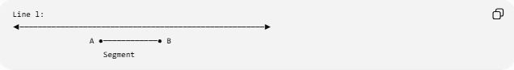
Line l:
◀──────────────────────────────────────────────────────▶
A ●────────────● B
Segment
The supporting line of $\overset{‾}{AB}$is uniquely determined when:
$$A≠B$$
and is written:
$$\boxed{\overset{↔}{AB}}$$
Therefore, every non-degenerate segment has exactly one supporting line.

Example 1: Horizontal Line
# Source: AI Source: Provided by: [Data Path: Persons Table -> ID Column: 1, Name_En Column: Motasem Essam] -> From: [ChatGPT] on [7/25/2026]
Let:
$$l:y=4$$
and:
$$A=\left(2 , 4\right), B=\left(9 , 4\right)$$
The segment is:
$$\overset{‾}{AB}$$
Every point on the segment has $y=4$.
Therefore:
$$\boxed{\overset{‾}{AB}⊆l}$$
So the segment and line are segment–line collinear.

Example 2: Vertical Line
# Source: AI Source: Provided by: [Data Path: Persons Table -> ID Column: 1, Name_En Column: Motasem Essam] -> From: [ChatGPT] on [7/25/2026]
Let:
$$l:x=5$$
and:
$$A=\left(5 , 2\right), B=\left(5 , 10\right)$$
Every point of $\overset{‾}{AB}$has:
$$x=5$$
Therefore:
$$\overset{‾}{AB}⊆l$$
and the segment is collinear with $l$.

Example 3: Oblique Line
# Source: AI Source: Provided by: [Data Path: Persons Table -> ID Column: 1, Name_En Column: Motasem Essam] -> From: [ChatGPT] on [7/25/2026]
Let:
$$l:y=2x+1$$
and:
$$A=\left(1 , 3\right) \\ B=\left(4 , 9\right)$$
Check $A$:
$$2\left(1\right)+1=3$$
Check $B$:
$$2\left(4\right)+1=9$$
Both endpoints lie on $l$.
Since the line through two distinct points is unique, the entire segment $\overset{‾}{AB}$lies on $l$:
$$\boxed{\overset{‾}{AB}⊆l}$$

Endpoint Test
# Source: AI Source: Provided by: [Data Path: Persons Table -> ID Column: 1, Name_En Column: Motasem Essam] -> From: [ChatGPT] on [7/25/2026]
For a straight line and a segment, there is a useful property:
If both endpoints of a segment lie on a line, the entire segment lies on that line.
If:
$$A∈l$$
and:
$$B∈l$$
then:
$$\boxed{\overset{‾}{AB}⊆l}$$
This follows from the fact that a line contains the entire straight path between any two of its points.

Coordinate Test
# Source: AI Source: Provided by: [Data Path: Persons Table -> ID Column: 1, Name_En Column: Motasem Essam] -> From: [ChatGPT] on [7/25/2026]
Suppose:
$$A=\left(x_{1} , y_{1}\right) \\ B=\left(x_{2} , y_{2}\right)$$
and the line is:
$$ax+by+c=0$$
The segment is collinear with the line if both endpoints satisfy:
$$ax_{1}+by_{1}+c=0$$
and:
$$ax_{2}+by_{2}+c=0$$
Therefore:
$$\boxed{\begin{aligned}ax_{1}+by_{1}+c&=0 \\ ax_{2}+by_{2}+c&=0\end{aligned}}$$
Then:
$$\overset{‾}{AB}⊆l$$

Parametric Representation
# Source: AI Source: Provided by: [Data Path: Persons Table -> ID Column: 1, Name_En Column: Motasem Essam] -> From: [ChatGPT] on [7/25/2026]
A line can be represented as:
$$r\left(t\right)=A+tv$$
where:
$$t∈R$$
A segment along the same line can be represented using a restricted parameter:
$$r\left(t\right)=A+t\left(B-A\right)$$
with:
$$\boxed{0≤t≤1}$$
Therefore:
Line: t ∈ ℝ
Segment: 0 ≤ t ≤ 1
The segment is simply a finite subset of the infinite line.

Segment–Line Collinearity vs. Segment Containment
# Source: AI Source: Provided by: [Data Path: Persons Table -> ID Column: 1, Name_En Column: Motasem Essam] -> From: [ChatGPT] on [7/25/2026]
These concepts are very closely related.
For a segment and a line, the condition:
$$\overset{‾}{AB}⊆l$$
can be described as segment containment in a line.
Thus:
- Segment–Line Collinearity emphasizes common straight-line alignment.
- Segment-in-Line Containment emphasizes the subset relationship.
They describe essentially the same geometric configuration from different perspectives.

Segment–Line Intersection
# Source: AI Source: Provided by: [Data Path: Persons Table -> ID Column: 1, Name_En Column: Motasem Essam] -> From: [ChatGPT] on [7/25/2026]
When a segment is collinear with a line:
$$\overset{‾}{AB}⊆l$$
their intersection is the entire segment:
$$\boxed{\overset{‾}{AB}∩l=\overset{‾}{AB}}$$
This is different from an ordinary transverse intersection, where a line crosses a segment at only one point.
Collinear
l ◀──────────────────────────────────▶
A ●────────────● B
$$l∩\overset{‾}{AB}=\overset{‾}{AB}$$
Non-collinear intersection
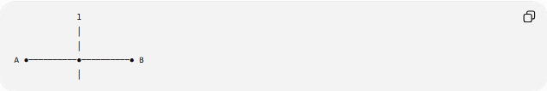
l
│
│
A ●──────────●──────────● B
│
Here:
$$l∩\overset{‾}{AB}=\left\{P\right\}$$
The line intersects the segment at only one point, so they are not collinear.

Segment–Line Relationship Types
# Source: AI Source: Provided by: [Data Path: Persons Table -> ID Column: 1, Name_En Column: Motasem Essam] -> From: [ChatGPT] on [7/25/2026]
For a segment and a line, their positional relationship can be classified as:
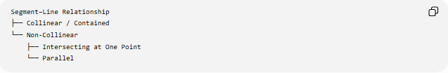
Segment–Line Relationship
├── Collinear / Contained
└── Non-Collinear
├── Intersecting at One Point
└── Parallel
For a segment and a line in the plane:
Collinear
$$\overset{‾}{AB}⊆l$$
Intersecting at One Point
$$\overset{‾}{AB}∩l=\left\{P\right\}$$
Parallel
$$\overset{‾}{AB}∩l=∅$$
with the segment's supporting line parallel to $l$.

Important Distinction: Parallelism
# Source: AI Source: Provided by: [Data Path: Persons Table -> ID Column: 1, Name_En Column: Motasem Essam] -> From: [ChatGPT] on [7/25/2026]
A segment can be parallel to a line without being collinear.
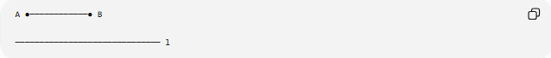
A ●────────────● B

────────────────────────────── l
The segment's supporting line and $l$are different parallel lines.
Therefore:
$$\boxed{\text{Parallel}≠\text{Collinear}}$$
For collinearity:
$$\overset{‾}{AB}⊆l$$

Example with Intersection
# Source: AI Source: Provided by: [Data Path: Persons Table -> ID Column: 1, Name_En Column: Motasem Essam] -> From: [ChatGPT] on [7/25/2026]
Suppose:
$$\overset{‾}{AB}$$
lies on:
$$y=3$$
and another line is:
$$x=5$$
The vertical line $x=5$can intersect the segment at:
$$\left(5 , 3\right)$$
But $x=5$is not the supporting line of the segment.
Therefore:
$$\overset{‾}{AB}$$
is collinear with $y=3$, but not with $x=5$.

Important Properties
# Source: AI Source: Provided by: [Data Path: Persons Table -> ID Column: 1, Name_En Column: Motasem Essam] -> From: [ChatGPT] on [7/25/2026]
- A segment–line collinearity relationship requires:
$$\overset{‾}{AB}⊆l$$
- Every point of the segment belongs to the line.
- Both segment endpoints lie on the line.
- A non-degenerate segment has exactly one supporting line.
- The line is infinite in both directions.
- The segment is finite.
- Their intersection is the entire segment:
$$l∩\overset{‾}{AB}=\overset{‾}{AB}$$
- A segment parallel to a line is not necessarily collinear with it.
- If both endpoints of a segment lie on a line, the entire segment lies on that line.
- Segment–line collinearity is a special case of Line-Object Collinearity.

Comparison with Other Line-Object Collinearity
# Source: AI Source: Provided by: [Data Path: Persons Table -> ID Column: 1, Name_En Column: Motasem Essam] -> From: [ChatGPT] on [7/25/2026]
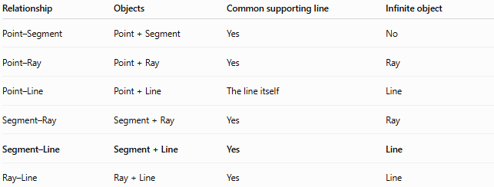
Relationship | Objects | Common supporting line | Infinite object
Point–Segment | Point + Segment | Yes | No
Point–Ray | Point + Ray | Yes | Ray
Point–Line | Point + Line | The line itself | Line
Segment–Ray | Segment + Ray | Yes | Ray
Segment–Line | Segment + Line | Yes | Line
Ray–Line | Ray + Line | Yes | Line

Segment–Line vs. Segment–Ray
# Source: AI Source: Provided by: [Data Path: Persons Table -> ID Column: 1, Name_En Column: Motasem Essam] -> From: [ChatGPT] on [7/25/2026]
The major difference is the extent of the second object.
Segment–Ray
$$\overset{‾}{AB}⊆l \\ \vec{CD}⊆l$$
The ray extends infinitely in one direction.
Segment–Line
$$\overset{‾}{AB}⊆l$$
The line extends infinitely in both directions.
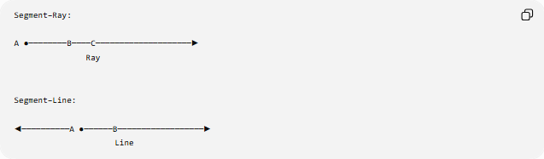
Segment–Ray:

A ●────────B────C────────────────────▶
Ray

Segment–Line:

◀──────────A ●──────B──────────────────▶
Line

Taxonomy
# Source: AI Source: Provided by: [Data Path: Persons Table -> ID Column: 1, Name_En Column: Motasem Essam] -> From: [ChatGPT] on [7/25/2026]
Geometric Relationships
└── Collinearity
└── Line-Object Collinearity
├── Point–Segment Collinearity
├── Point–Ray Collinearity
├── Point–Line Collinearity
├── Segment–Ray Collinearity
├── Segment–Line Collinearity
└── Ray–Line Collinearity

Key Points
# Source: AI Source: Provided by: [Data Path: Persons Table -> ID Column: 1, Name_En Column: Motasem Essam] -> From: [ChatGPT] on [7/25/2026]
- Segment–Line Collinearity means a finite segment lies entirely on an infinite straight line.
- The fundamental condition is:
$$\boxed{\overset{‾}{AB}⊆l}$$
- Both endpoints of the segment lie on the line.
- Every point between the endpoints also lies on the line.
- The intersection is the entire segment:
$$\boxed{l∩\overset{‾}{AB}=\overset{‾}{AB}}$$
- Parallelism and collinearity are different relationships.
- Segment–line collinearity can also be viewed as segment containment in a line.

Conclusion
# Source: AI Source: Provided by: [Data Path: Persons Table -> ID Column: 1, Name_En Column: Motasem Essam] -> From: [ChatGPT] on [7/25/2026]
Segment–Line Collinearity describes the relationship between a finite line segment and an infinite line when the entire segment lies on that line. Because the segment is a finite portion of its supporting line, the defining mathematical relationship is:
$$\boxed{\overset{‾}{AB}⊆l}$$
This makes Segment–Line Collinearity both a collinearity relationship and, from a set-theoretic perspective, a containment relationship.

